Cross-quantilogram: EURUSD and USDJPY
Method 20 / daily log returns / expanding quantiles / Alpari D1 full available history

Study setup
Logical pair: EURUSD , USDJPY
Broker symbols: EURUSD_i , USDJPY_i
Snapshot: 2026-11-03_majors_alpari_D1
Timeframe: D1
Matched return window: 1999-01-05 to 2026-11-02 (UTC bar dates)
Matched return count n: 7200
Dropped unfinished last bar dated 2026-11-03 UTC after a tick-volume check against the prior complete day.
Quantiles: expanding window, min history 252 days
tau in [0.05, 0.2]; k=0..10; headline tau=0.05, k=1
Complete matched rows (Excel): EURUSD-USDJPY_CQ_D1.xlsx
Complete matched rows (HTML table): EURUSD-USDJPY_CQ_D1_data.html

Method carried forward
The cross-quantilogram rho_tau(k) measures linkage among centered quantile-hit indicators of matched daily log returns of close, ln(close_t / close_t-1). Quotes are not inverted. At each date t, the tau-quantile uses only returns through t (expanding window) after a minimum history of 252 days. Hits are h_t = 1(r_t < q_t) - tau. rho_tau(k) is the normalized cross-product of h_x,t with h_y,t+k. Levels tau in {0.05, 0.20} and lags k=0..10 are pre-specified; headline is tau=0.05, k=1 both directions. Same-sample Pearson r is a side check. This is not causation and not a trading signal.

Results (headline)
rho_EURUSD->USDJPY(tau=0.05,k=1): 0.030735
rho_USDJPY->EURUSD(tau=0.05,k=1): 0.034665
rho_EURUSD->USDJPY(tau=0.20,k=1): 0.038308
rho_USDJPY->EURUSD(tau=0.20,k=1): 0.040339
Pearson r: -0.300952

CQ table (tau=0.05)
k | rho_EURUSD_to_USDJPY | n_EURUSD_to_USDJPY | rho_USDJPY_to_EURUSD | n_USDJPY_to_EURUSD
0 | 0.0307446 | 6949 | 0.0307446 | 6949
1 | 0.03073508 | 6948 | 0.0346654 | 6948
2 | 0.0267952 | 6947 | 0.02286485 | 6947
3 | 0.01499446 | 6946 | 0.02285525 | 6946
4 | 0.05821955 | 6945 | 0.03070652 | 6945
5 | -0.00074679 | 6944 | 0.05034936 | 6944
6 | 0.01103491 | 6943 | 0.02282645 | 6943
7 | 0.03853905 | 6942 | 0.02281685 | 6942
8 | 0.01887666 | 6941 | 0.03066843 | 6941
9 | 0.00707513 | 6940 | 0.01100576 | 6940
10 | 0.02671871 | 6939 | 0.05030272 | 6939

Conclusion
Headline tau=0.05, k=1 for EURUSD and USDJPY: rho_EURUSD->USDJPY = 0.0307; rho_USDJPY->EURUSD = 0.0347. At tau=0.20, k=1: 0.0383 and 0.0403. Same-day tau=0.05 rho(k=0) = 0.0307. Pearson r = -0.3010. This is quantile-hit linkage, not a trading signal.

Charts
Daily closes

Daily log returns

Cross-quantilogram tau=0.05
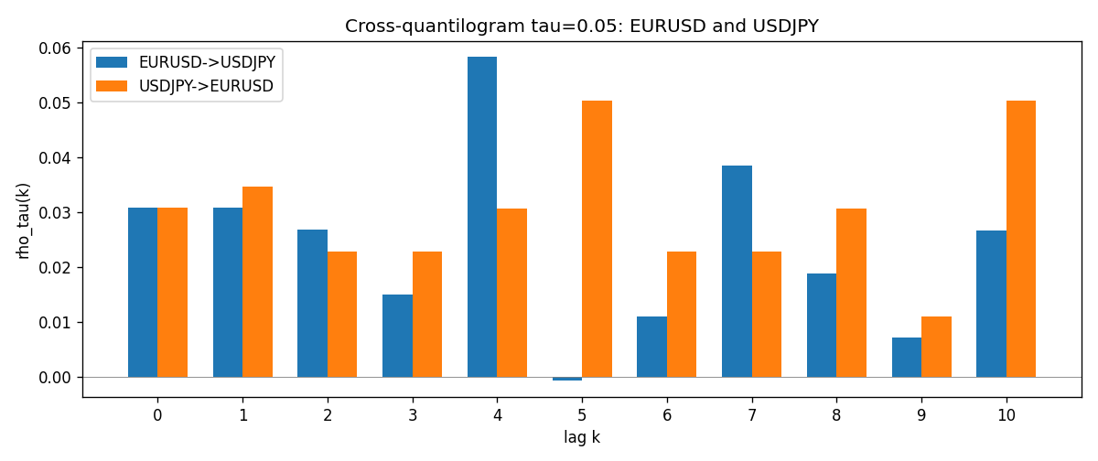

Data report
Matched rows and the CQ sheet are in the sibling Excel workbook named EURUSD-USDJPY_CQ_D1.xlsx. Embedding all rows as a Word table is impractical; this file holds column summaries and the first and last 15 matched rows.
Columns: time, EURUSD_open, USDJPY_open, EURUSD_high, USDJPY_high, EURUSD_low, USDJPY_low, EURUSD_close, USDJPY_close, EURUSD_tick_volume, USDJPY_tick_volume, EURUSD_spread, USDJPY_spread, EURUSD_real_volume, USDJPY_real_volume, EURUSD_log_return, USDJPY_log_return, EURUSD_h_t005, USDJPY_h_t005
Column summaries (matched calculation rows)
column | count | mean | std | min | 25% | 50% | 75% | max
EURUSD_open | 7200 | 1.1812699 | 0.15089907 | 0.8272 | 1.086045 | 1.16609 | 1.2939325 | 1.5995
USDJPY_open | 7200 | 113.80877 | 19.206548 | 75.693 | 104.4225 | 110.983 | 120.69125 | 163.824
EURUSD_high | 7200 | 1.1864006 | 0.15149686 | 0.8326 | 1.0901575 | 1.17121 | 1.2991625 | 1.6038
USDJPY_high | 7200 | 114.3063 | 19.268128 | 76.001 | 104.878 | 111.441 | 121.26 | 163.978
EURUSD_low | 7200 | 1.1762568 | 0.15022122 | 0.8227 | 1.0819775 | 1.162475 | 1.288265 | 1.5865
USDJPY_low | 7200 | 113.28572 | 19.134551 | 75.402 | 103.8875 | 110.53 | 120.17 | 163.628
EURUSD_close | 7200 | 1.1813075 | 0.15087411 | 0.8267 | 1.085995 | 1.16602 | 1.2939425 | 1.5997
USDJPY_close | 7200 | 113.82186 | 19.221964 | 75.811 | 104.4165 | 111.023 | 120.6855 | 163.851
EURUSD_tick_volume | 7200 | 103020.56 | 173417.03 | 218 | 9398.5 | 52714 | 99443.25 | 1471626
USDJPY_tick_volume | 7200 | 106139.77 | 179306.98 | 149 | 9927.5 | 53095 | 92761 | 1803508
EURUSD_spread | 7200 | 19.389444 | 16.57873 | 0 | 8 | 12 | 30 | 50
USDJPY_spread | 7200 | 20.3175 | 17.636173 | 0 | 6 | 11 | 30 | 50
EURUSD_real_volume | 7200 | 4.0252061e+10 | 1.6676396e+11 | 0 | 0 | 0 | 0 | 3.6149665e+12
USDJPY_real_volume | 7200 | 3.4708591e+10 | 1.6077621e+11 | 0 | 0 | 0 | 0 | 3.8834203e+12
EURUSD_log_return | 7200 | -1.012e-05 | 0.00580063 | -0.03123819 | -0.0032472 | 0 | 0.00325137 | 0.03433183
USDJPY_log_return | 7200 | 4.989e-05 | 0.00620383 | -0.03908203 | -0.00319719 | 0.00011638 | 0.00340925 | 0.05184024
EURUSD_h_t005 | 6949 | -0.01675781 | 0.17928127 | -0.05 | -0.05 | -0.05 | -0.05 | 0.95
USDJPY_h_t005 | 6949 | -0.00682832 | 0.20325804 | -0.05 | -0.05 | -0.05 | -0.05 | 0.95
First 15 matched rows (selected columns)
time | EURUSD_log_return | USDJPY_log_return | EURUSD_h_t005 | USDJPY_h_t005
1999-01-05 | -0.0048360507 | -0.00017868311 | nan | nan
1999-01-06 | -0.011547966 | 0.0075660159 | nan | nan
1999-01-07 | 0.0076280636 | -0.012851583 | nan | nan
1999-01-08 | -0.010902799 | -0.0047719894 | nan | nan
1999-01-11 | -0.007103287 | -0.016195423 | nan | nan
1999-01-12 | 0.0045103728 | 0.032310364 | nan | nan
1999-01-13 | 0.010845346 | 0.0081373171 | nan | nan
1999-01-14 | 0 | 0 | nan | nan
1999-01-15 | -0.010153245 | 0.0055343401 | nan | nan
1999-01-18 | 0.0036256946 | 8.7600193e-05 | nan | nan
1999-01-19 | -0.00017235436 | -0.0056219403 | nan | nan
1999-01-20 | -0.0031939256 | -0.0053879917 | nan | nan
1999-01-21 | 0.0030215416 | 0.0084664056 | nan | nan
1999-01-22 | -0.0012075213 | 0.0060412564 | nan | nan
1999-01-25 | -0.0030251979 | -0.0073594164 | nan | nan
Last 15 matched rows (selected columns)
time | EURUSD_log_return | USDJPY_log_return | EURUSD_h_t005 | USDJPY_h_t005
2026-10-13 | 0.0037402957 | -0.0018932826 | -0.05 | -0.05
2026-10-14 | -0.0037582255 | 7.5800166e-05 | -0.05 | -0.05
2026-10-15 | 0.0056053107 | -0.0018524319 | -0.05 | -0.05
2026-10-16 | 0.0017724895 | -0.00037976126 | -0.05 | -0.05
2026-10-19 | -0.0025394633 | 0.0034946841 | -0.05 | -0.05
2026-10-20 | 0.0023881672 | -0.0022546642 | -0.05 | -0.05
2026-10-21 | -0.00032046717 | -0.00032883504 | -0.05 | -0.05
2026-10-22 | -0.0015949606 | -0.0085942669 | -0.05 | -0.05
2026-10-23 | -0.001338521 | 0.00035080446 | -0.05 | -0.05
2026-10-26 | -0.0022706559 | 0.0041238746 | -0.05 | -0.05
2026-10-27 | -0.004152342 | 0.0027651658 | -0.05 | -0.05
2026-10-28 | 0.0022262927 | -0.00095679538 | -0.05 | -0.05
2026-10-29 | 0.0022571351 | -0.00038043789 | -0.05 | -0.05
2026-10-30 | -0.0011458446 | -0.0010596481 | -0.05 | -0.05
2026-11-02 | 0.002120569 | 0.0026438521 | -0.05 | -0.05

